H.T No
Regulations:
A14

Sreenidhi Institute of Science and Technology
(An Autonomous Institution)
Code No: 4H315 Date: 08-Oct-2020 (FN)

B.Tech II-Year I-Semester External Examination, October - 2020 (Supplementary)
Engineering Mathematics-III (Common to All Except BT)

Time: 2 Hours Max.Marks:70

Note: a) No additional answer sheets will be provided.
b) All sub-parts of a question must be answered at one place only, otherwise it will not be valued.
c) Missing data can be assumed suitably.

ANSWER ANY FIVE QUESTIONS. EACH QUESTION CARRIES 14 MARKS.

1. | a) | Compute 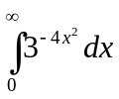 using Beta and Gamma functions. | [7M]
 | b) | Show that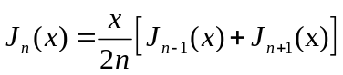. | [7M]
2. | a) | Show that the function 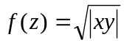 satisfy Cauchy-Riemann equations but not analytic at the origin | [7M]
 | b) | Compute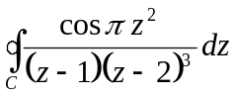, where C is 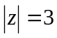 by using Cauchy integral formula | [7M]
3. | a) | Determine the Fourier cosine transform of 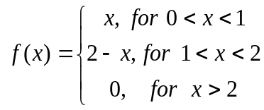 | [7M]
 | b) | Determine the Fourier Transform of 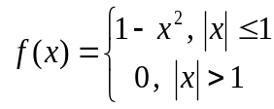 | [7M]
4. | a) | Using bisection method find the approximate root of the equation  x³-x-1=0 . | [7M]
 | b) | Compute 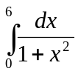 by using Simpson’s rule | [7M]
5. | a) | Determine 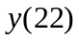using Newton’s backward difference formula, from the following data | [7M]
   | 4 | 8 | 12 | 16 | 20 | 24
   | 65 | 17 | 1 | 17 | 65 | 145
 | b) | Compute the polynomial such that using Lagrange’s interpolation formula | [7M]
6. | a) | Using Taylor’s method, solve 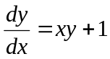 with 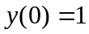 at 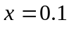 | [7M]
 | b) | Using Runge- Kutta method of fourth order, solve 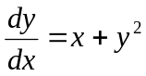 with at 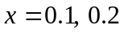 | [7M]
7. | a) | Compute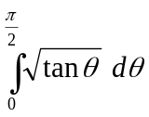 using Beta and Gamma functions | [7M]
 | b) | Compute by residue theorem 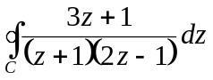 where 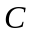is the circle 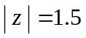 | [7M]
8. | a) | Compute a fourth root of 32 correct to 4 decimal places by Regula Falsi method | [7M]
 | b) | 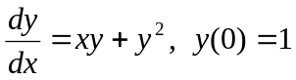 compute 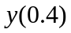 by Milne’s method when | [7M]

-- 00 -- 00 –

